# Database and data distribution

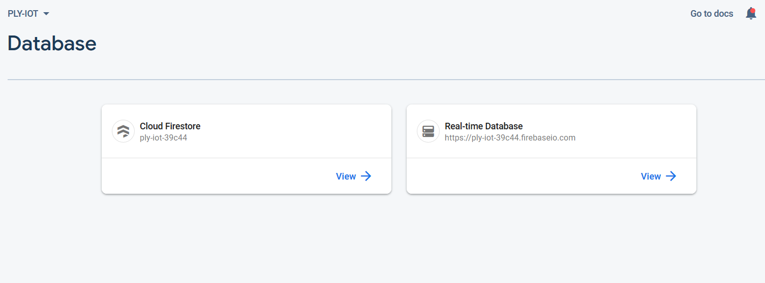We used NoSQL based Google Firebase for out database platform. The sensor wise data that needed to be retrieved and monitored directly are stored in the Realtime database partition. Other data such as tank levels and setting that doesn’t need constant updates are stored in cloud fire store traditional database. Both controller and web applications are linked to the database for monitor and analytical purposes

Real-time database introduction

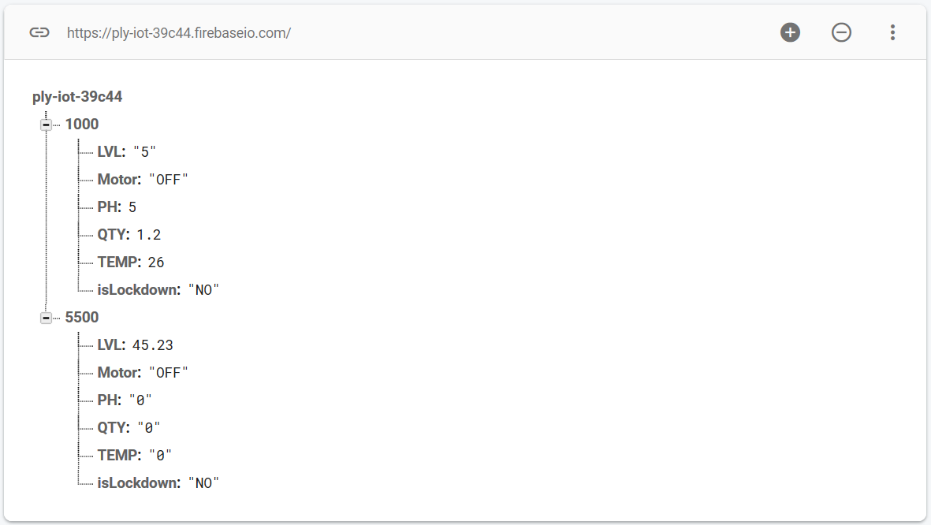

Inside Real-time Database live reading picked up by sensors are stored and send to monitoring applications. Each device has a unique document reserved inside you can see live reading as a key value paired couples. Each key value pair shows different read picked up by a dedicated sensor or a tank status derived by those readings

1000,5000 represents different tank data documents

Cloud firestore

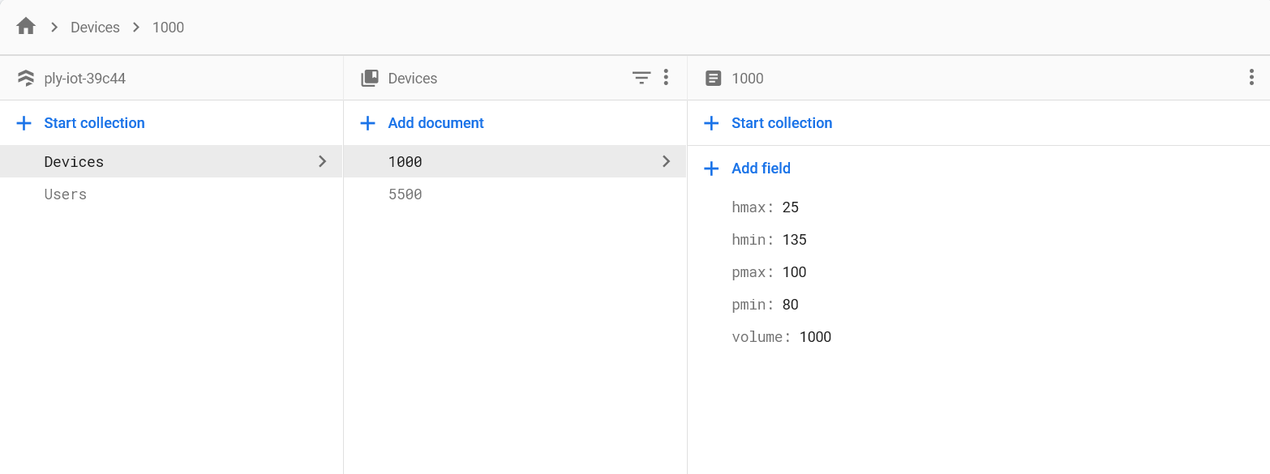

Device collection holds the user defined level data for Realtime firebases devise’s settings (tanks min level and overflow level etc.). These data can change by the access of the web application therefore you can adjust tanks water filling level via settings interface

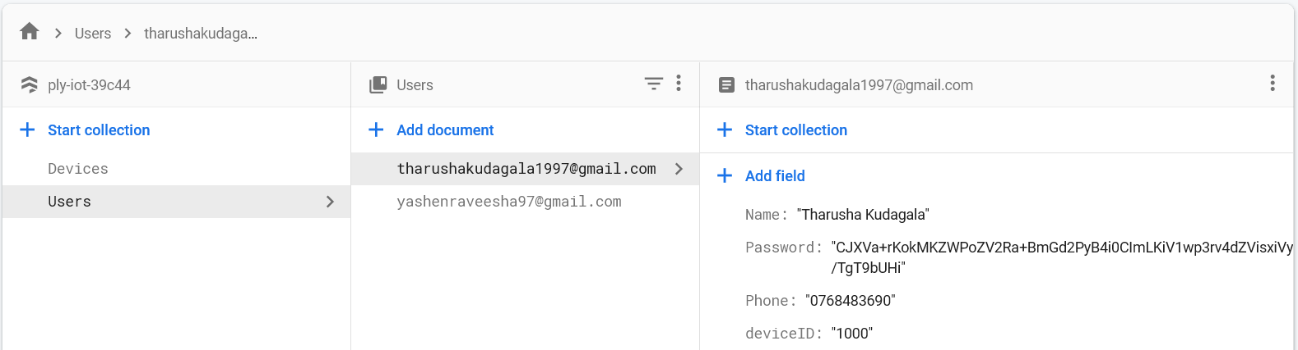

Users collection contains user biodata and passwords with the data makes your identity unique